Investigation of vapor cryodeposited glasses and glass transition of tetrachloromethane films

A. Shinbayeva, A. Aldiyarov, A. Drobyshev, A. Nurmukan, D. Sokolov
Kazakh National University, Institute of Experimental and Theoretical Physics,
050071 Almaty, 71 al-Farabi ave, Kazakhstan

Establishing a connection between the molecules structure and their cryodeposited conditions on the one hand, and the glass properties formed at low temperatures, such as the degree of kinetic stability, on the other hand, it is an important and hitherto completely unsolved problem of physical-chemistry condensed matter. The organic molecules in combination with the method of their gas-phase cryocondensation provide wide experimental possibilities for studying the glasses and their thermally stimulated transformations, including glass transitions [1, 2]. The object of investigation is tetrachloromethane. In the process of studying the effect of molecules anisotropy on the kinetic characteristics of glasses formed at low temperatures [3].
The results of IR-spectrometric studies of CCl₄ cryovacuum condensates thin films formed on a metal substrate in the temperature range from 16 to 100 K and gas phase pressures P=10⁻⁵ Torr are demonstrated. The thermograms of the absorption band position changing are analyzed, which are a consequence of thermostimulated transformations in the CCl₄ cryofilm.

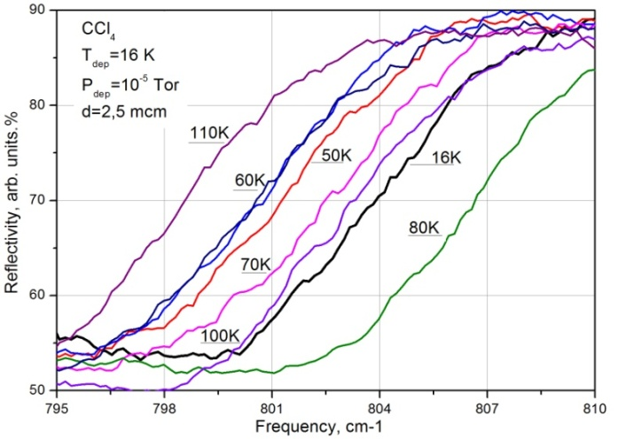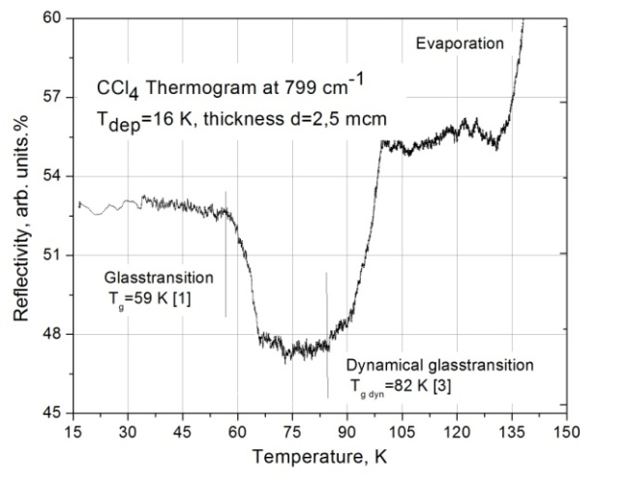
The left figure shows fragments of absorption spectra of CCl₄ cryogenic film 2.5 μm thick, obtained at these heating temperatures. The right figure shows the corresponding thermogram obtained at the observation frequency ν = 799 cm⁻¹. The thermogram behavior features correspond to the temperature intervals of the structural transformations shown in the figure in the sample.

1. O. Haida, H. Suga, and S. Seki, J. Chem. Thermodyn. 9, 1133–1148 (1977).
2. T. Takei, Y. Onoda, M. Fuji, T. Watanabe, and M. Chikazawa, Thermochim. Acta 352-353, 199–204 (2000).
3. Y.Z. Chua, M. Tylinski, S. Tatsumi, M.D. Ediger, C. Schick, J. Chem. Phys. 144, 244503 (2016)

